Algebra 2/Trigonometry 1 Name:______________________________________
The table lists the average total cost of attending a 4-year college during the years 2000-2009.
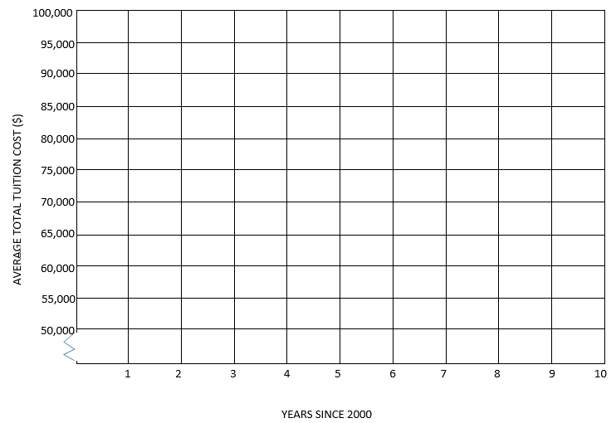
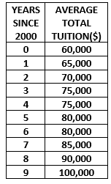

Equation of the Line of Best Fit : Prediction for total tuition cost for graduating in 2016:

___________________________ ___________________________

